
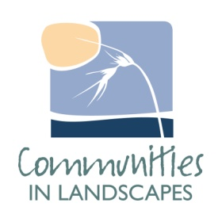
Numeralla Landcare Inc

Seed Collecting Workshop

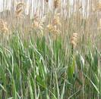
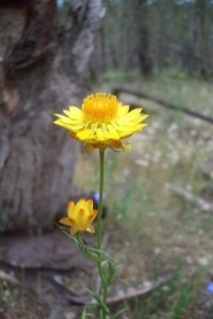
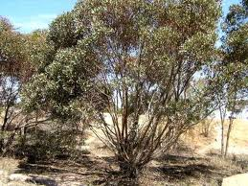
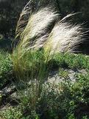
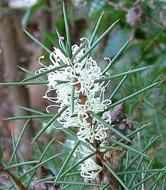
18th June, 2011
10:00-2:30pm
Numeralla Hall + site visit

Join Greening Australia and Numeralla Landcare for a free seed collecting workshop to learn about how to collect a variety of local native plant seed, followed by a site visit to practice seed collecting methods. (Please note that due to the time of year and seeding times of local plants, the total amount of seed that can be collected on this day will be limited.)

Cost: Free, morning tea& lunch provided
Please RSVP by 15th June toAntia (0429778633)
Supported by:

