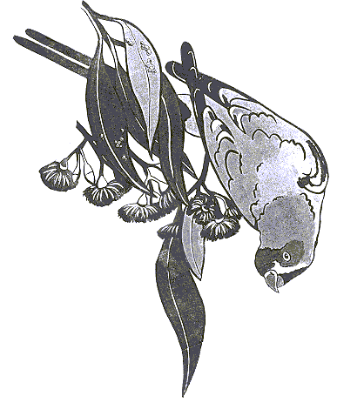
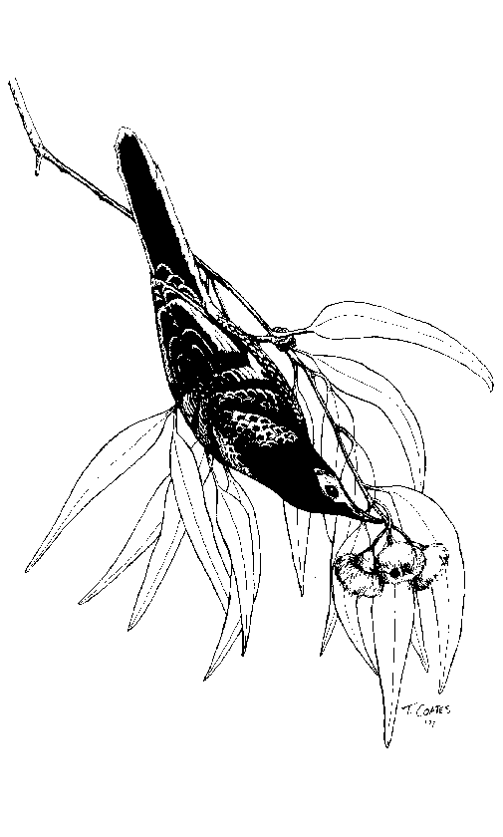
Swift Parrot-Regent Honeyeater Record Sheet
Observer Name/s:
Postal Address:
Mobile: Home or Work Ph: (…)
Email:

Site Details
Location (or distance and direction from nearest named landmark or town):

Date: Time started: Time finished: ….
Number of observers:………………………………..Altitude (if known):

Map details (Map No, Name and Scale not required if GPS co-ords provided)
Map No: …… Map Name & Scale: …………………………GPS used: Yes/No GPS Datum:………….
Easting: ……………...Northing: ………………..(e.g. East: 243560 North: 6027450) Zone………. (e.g. 55 or 56 )
Lat: …..Long: …(e.g. Lat: 33º40’15” Long: 150º45’10”)

Swift Parrot (SP) / Regent Honeyeater (RH) observations
Swift Parrots seen / heard (including zero):……………………………………….
Regent Honeyeaters seen / heard (including zero):……………………………………….
Details of activity (e.g. foraging, aggression, perching, calling etc):

Food/Habitat Resources Used:

Other nectivorous bird species present (regardless of whether SP/RH recorded)
Other nectivorous species present (e.g. Honeyeaters, Lorikeets) | Abundance  (estimate no. of birds) | Interaction with SP/RH  (e.g. aggression / competing for food resources)

Habitat / Site Description
Please describe any relevant details about the site such as topography, vegetation, presence / absence of mistletoe and if possible the species and size of trees being used by SP/RH: ………………………………………………….
……………………………………………………………………………………………………………………………………………………………………………………………………………………………………………………

Site Map/Additional Information
Please include any additional information (e.g. simple map, shrub species present, direction of flight, additional birds. etc) on the other side of this form.

