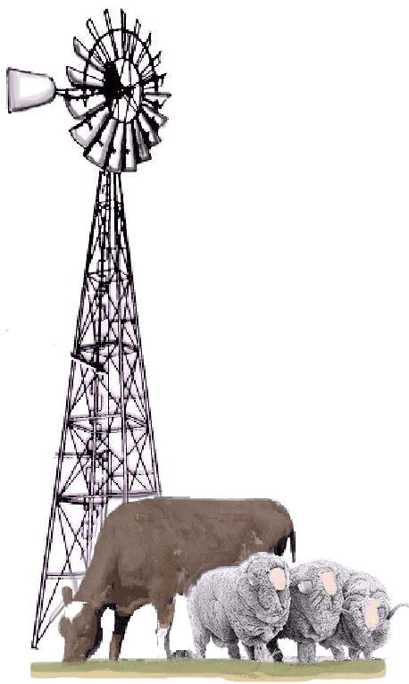
Rural Financial Counselling Service
NSW - Southern Region
COOMA
PO Box 761
COOMA 2630
T: 02 6452 5059
F: 02 6452 3766
COLEAMBALLY
39 Brolga Place
COLEAMBALLY 2707
T: 02 6954 4179
F: 02 6954 4420
COWRA
PO Box 183
COWRA 2794
T: 02 6341 1244
F: 02 6324 4668
CROOKWELL
PO Box 58
CROOKWELL 2583
T: 02 4832 0070
F: 02 4832 0071
DENILIQUIN
PO Box 937
DENILIQUIN 2710
T: 03 5881 5766
F: 03 5881 3781
GANMAIN
PO Box 65
GANMAIN 2702
T: 02 6927 6622
F: 02 6927 6633
GRIFFITH / LEETON
PO Box 1059
GRIFFITH 2680
T: 02 6964 2420
F: 02 6964 2409
HAY
PO Box 224
HAY 2711
T: 02 6993 4130
F: 02 6993 4140
IVANHOE
Columbus Street
IVANHOE 2675
T: 02 6995 1109
LAKE CARGELLIGO
30a Foster Street
LAKE CARGELLIGO 2672
T: 02 6898 1151
F: 02 6898 1153
WEST WYALONG
89-91 Main Street
WEST WYALONG 2671
T: 02 6972 3645
www.rfcsnsw-sr.com.au

HEAD OFFICE COOMA Ph: 0264 525 059

IAN MCGUFFICKE Mob: 0408 435 263

LEANNE JARDINE COOMA T: 02 6452 5059
M: 0447 467 964

GRAHAM CHRISTIE COLEAMBALLY T: 02 69 544 179
M: 0438 444 540

DARREN MCCARTNEY HAY T: 0269 934 130
M: 0410 622 599

MURRAY FRESHWATER DENILIQUIN T: 0358 815 766
M: 0428 815 766

EDDIE REDFERN GANMAIN T: 0269 276 622
M: 0447 479 694

LISA MINOGUE WEST WYALONG T: 0269 721 688 M: 0447 283 688

GREG PAUL COWRA T: 0263 411 244
M: 0427 935 823

CATH CARTER CROOKWELL T: 0248 320 070
M: 0400 452 434

CARL SCOOPE GANMAIN M: 0427 895 633

LINDA MCLEAN HILLSTON T: 0268 981 151

IVANHOE T: 0269 951 109
M: 0428 274 846

BEVERLY HOUTERMAN YASS T: 0263 452 235
M: 0448 409 495

KEVIN MCCRUM LEETON–GRIFFITH T: 02 6964 2420
M: 0448 642 444

