Growing grass for grapes
by Paul Griffiths 21 June 2013
For a vigneron, James Sweetapple pays a lot of attention to grass.
It's not just that he encourages grass growth in 16 hectare Cargo Road Wines vineyard near Orange: he manages that growth using concepts developed on the African savannah.
While other vineyards slash and spray to maintain grass at the level of a bowling green, Mr Sweetapple allows a suite of grass, herbs and forbs to grow to up to a metre in height, and then packs 250 sheep per hectare onto the growth to eat and trample the pasture.
The resulting mulch, amply fertilised by dung and urine, helps Cargo Road make more thrifty use of water, boosts soil fertility and minimises use of herbicide.
Mr Sweetapple's grass strategy, and the outcomes of that strategy, are partly due to a process called "holistic management".
Holistic management was developed by Rhodesian game ranger, farmer and guerrilla soldier, Allan Savory, who initially developed the principles to combat desertification of grasslands.
Mr Savory conceived a system of planned grazing that mimics the conditions of the African savannah, where grass is annually cycled back into the soil through the grazing, trampling and defecation of great herds of grazing animals, mobbed together by some of the world's best predators.
The system has been used with success by land managers on four continents, including Australia. Cargo Road Wines is possibly one of the smallest areas the concept has been applied to.
Mr Savory, who is visiting Australia in early August, has spent half a century refining his grazing ideas within the wider frame of holistic management, which promotes "triple bottom line" decision-making.
Until recently Mr Savory's concepts earned little recognition, but in 2010 he was awarded the $100,000 Buckminster Fuller Challenge for solutions to intractable global problems. The video of a recent TED talk by Mr Savory has gone viral, receiving about 1.7 million views.
Mr Sweetapple learned about holistic management through a new TAFE Western course taught by fully accredited Holistic Management Educators.
The process taught him to view his decisions from a fresh perspective.
"It gives me more structure for making decisions," he says. "It prompts me to think about where we're going, and how I need to get there. When I settle on a decision, I have more confidence that it was the best I could make at the time. And then I monitor the outcomes closely, just in case I was wrong."

Mr Sweetapple had always run sheep in the vineyard during winter, but the training made him reconsider how he did it. Using short grazes perhaps one or two days and then long recovery grazing techniques with a tightly bunched flock puts more litter on the ground and concentrates dung and urine.
His vineyard has little irrigation water available to it, and the extra moisture stored in the growing organic carbon content of his soils is invaluable for getting through central NSW's periodic dry spells.
The mulch of trampled vegetation takes most of the work out of managing weeds, and he has much less reliance on herbicide to manage the vineyard.
The net result is less money spent on diesel and other inputs, and less time in the tractor seat, with more time and money to invest elsewhere in the business.
He has other environmental projects around the property, and the ongoing challenge of positioning Cargo Road Wines in a competitive market.
For 13 of the 16 years he has been a vigneron, Mr Sweetapple says, the grape business has been tough because of oversupply and overseas competition.
After learning the principles of holistic management, "I was re-energised".
"I learned so much. I became excited about what I was doing all over again, and I gained a community of other holistic managers that I talk to virtually every week."
"I'm no longer just grinding along. I'm excited to see what happens next."

Allan Savory will deliver the inaugural Bruce Ward and George Gundry Legacy Lecture at the Day After Tomorrow conference in Orange on August 6.
Bruce Ward was instrumental in disseminating Mr Savory's ideas in Australia. George Gundry was a holistic management practitioner and educator. Both men died within the last year.
Mr Savory will also be talking in Lismore and Dubbo, NSW; Warwick, Qld; and Mataranka, NT.

More information: www.tasteorange.com.au or Conference Convenor, Paul Griffiths: paul@reasontospeak.com; 02 9144 3975
James Sweetapple is available for further interview - Mb: 0428 656 100

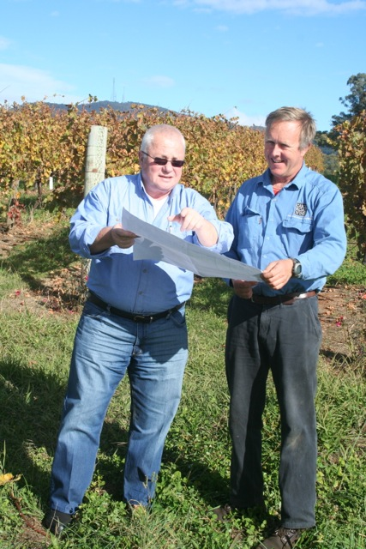
Vigneron James Sweetapple (right) and TAFE Educator Paul Griffiths using an holistic grazing plan to decide how to run James' wethers in among the vines at Cargo Road Wines.

