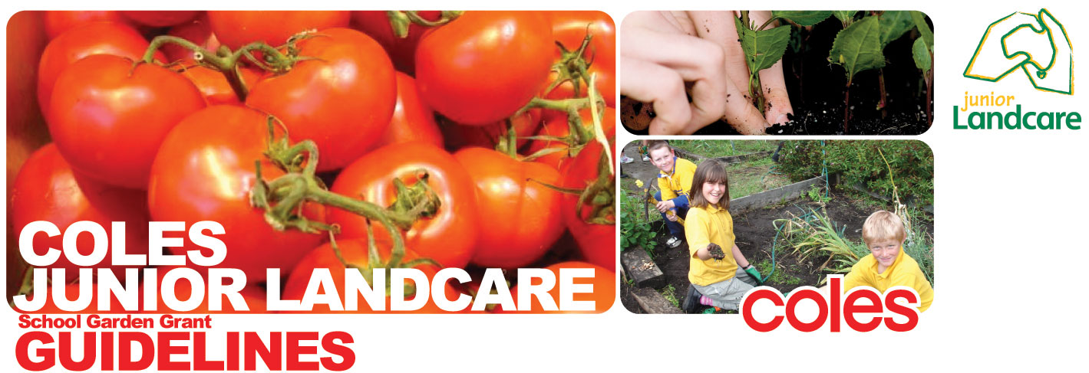


What activities does the Coles Junior Landcare Garden grant support?
- Bush Tucker gardens
- Vegetable gardens
- Composting and green waste recycling activities
- Awareness raising of food miles through growing your own produce
- Waterwise and Carbon gardening activities
- Purchase of kids gardening equipment (gloves, shovels etc) up to the value of $500.
Preference will be given to those applications which
- Demonstrate strong environmental education outcomes and links to school curriculum
- Involve the following groups:
  - landcare groups and Natural Resource Management Organisations
  - local government
  - parents, the wider community and community groups

  - local business
- Promote leadership and environmental stewardship
- Directly engage students in on-ground environmental sustainability activities
- Support a range of activities
Activities not supported by this grant
- Construction or upgrade of seating
- General beautification of the school
- Airfares, teacher wages or other travel costs
- Water tanks or irrigation equipment totaling more than 50% of funding sought
- Purchase of cooking equipment
- Administration and labor costs
- Construction of garden sheds
- Purchase of lawnmowers
- Purchase of flowers or turf
- Landscaping

Who Can Apply?
Any school or youth group seeking to educate young Australians about the environment.
If your group is not incorporated you will need to form a partnership with an organisation that will (and can) accept responsibility for administering the financial aspects of your grant, for example an incorporated Landcare or catchment organisation.
Your application will be assessed on its:
- Expected educational and environmental benefits.
- Expected level of student/youth involvement, e.g. students identifying local problems and designing and implementing solutions.
- Expected level of involvement of the broader school community or local community, eg. Links with a Landcare Group or Network.
- Integration into the school curriculum or youth group program to maximise environmental learning.
- Potential to develop the school’s/group’s skills and ability to contribute to environmental restoration in the future.
- Project activities and budget, which must be feasible and technically-sound.
- Merit, equity and need.
- Practical and sustainable activities.
- NB. Priority will be given to schools/groups that have not received a Junior Landcare Grant in the current calendar year.
How much is available?
Coles Garden grants are up to $1,100 (including GST) and are available quarterly


Can I apply if I have received funding from Landcare in the past?
Yes, however priority will be given to those schools/groups who have not received a Junior Landcare grant in the current calendar year.
Can I apply for more than one type of grant in a grant round?
Yes, however the maximum number of grants you will be awarded in any given round is one.
Can I submit my application after the closing date?
Late applications will not be considered for funding
Where must I undertake my project?
Within the school (or youth group) grounds, or in an area of community concern, with the prior permission of the landholder to carry out the project on their land.
How do I obtain an application form?
Head to the funding pages on the landcareonline website at LandcareOnline - Community, corporates, government working together for a sustainable environment
How many grants are available?
Junior Landcare awards approximately 200 Coles grants per year
When can I expect to start and when do I need to have my project completed?
Landcare Australia advises applicants of the outcome of their application approximately one month after the closing date of a funding round. If successful, grant funds must be spent on the project budget items within six months of receiving funds however the project may be ongoing.

If successful, what are my obligations?
- Conduct the project according to the activities and budget for which the funding was approved and received.
- Provide a final report on outcomes of the project, including how funds were spent, within 6 months of receiving funds.
- Permit Landcare Australia and partners to use your project final report and photos for promotional purposes.

