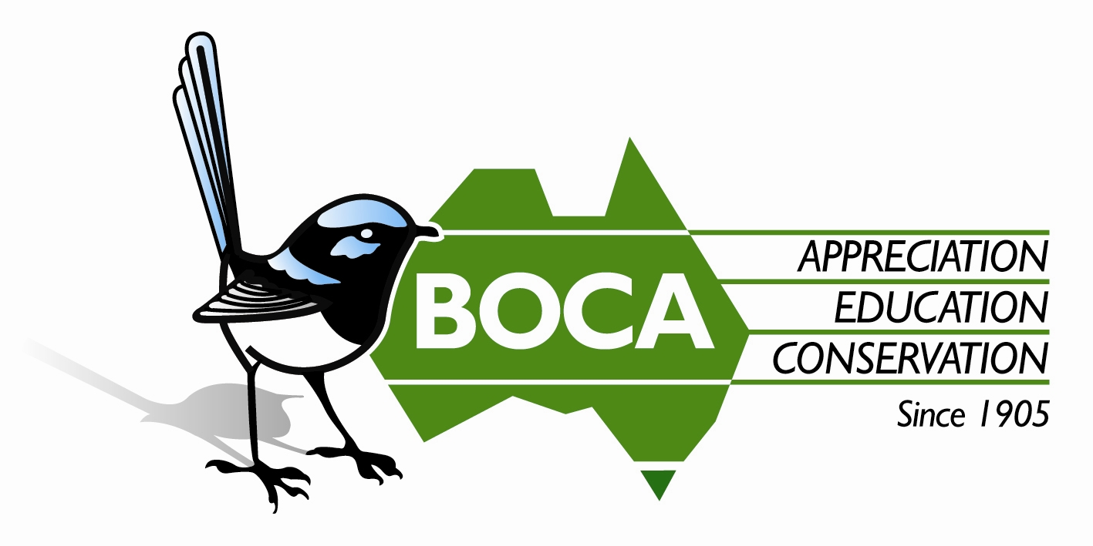
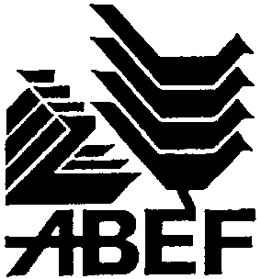

Bird Observation & Conservation Australia
ABN 24 005 068 842

183-185 Springvale Rd (PO Box 185) Nunawading, Vic 3131 Australia
Tel: 03 9877 5342 Fax: 03 9894 4048
Email: admin@boca.org.au Web: www.boca.org.au

Application for Funding

Office Use Only: Application No.________________

BOCA accepts applications for financial assistance for projects pertaining to Australian native birds and their habitats from any person or institution (whether public or private) to:

- Undertake research and investigation
- Carry out voluntary conservation work
- Develop and execute education and information programs
- Develop management plans or techniques

Application Details
In completing this Application please follow the instructions in the Guidelines for Making a Funding Application attached.

Name of Applicant/s or Organisation

If an Organisation, Name of Contact

Address for Correspondence

State Postcode

Telephone Fax Email

Title of Project

Signature of Applicant/s

Date of Application

Applications for funding close on 31 May each year. Allow adequate time for postage and delivery. Under special circumstances applications may be considered at other times.

Please send applications to: BOCA, Conservation Grants Scheme, PO Box 185, Nunawading, Vic 3131.

Enquiries: Email: admin@boca.org.au Tel: 03 9877 5342 Fax: 03 9894 4048.

Nature of Project:
Please outline the aims of the specific project for which funding is being sought and explain how the aims of the project will be achieved.

Significance with respect to the aims of BOCA:
Please state how, in your view, the project will contribute to the objects of the BOCA Conservation Grant Scheme as set out on Page 1 of the Application.

How did you hear about the BOCA Conservation Grant Scheme?

◻ In BOCA publications or web page
◻ Other Conservation Organisation:

◻ Other source:

Relationship to any other programs
Is your project part of a larger ongoing program? Yes/No

If yes, please explain the aims of the ongoing program and its relationship with the project for which you are seeking funding.

Duration of this Project:

Anticipated or Actual Commencement Date

Anticipated Completion Date
Funding:
Amount of Funding sought: $

Please state briefly the basis on which you arrived at the sum requested and attach all relevant quotations.

Are you receiving any other financial support? Yes/No

If yes, how important is the support of the BOCA Conservation Grant Scheme to the successful completion of the project?

Property Ownership:
If any aspect of this project involves work on or improvements to privately owned property, satisfactory evidence of ownership must be provided (copy of title or Statutory Declaration). If the applicant is not the sole owner of the property then the consent, in writing, of all parties must accompany this application.

Statement of Applicant/s:

I/We declare that to the best of my/our knowledge the information contained in this Application is correct and acknowledge that the Trustees’ decision is final.

Signed:

Date:

Supporting information must be attached to this application.

BOCA Conservation Grants are funded by Australian Bird Environment Foundation (ABEF)
which is the Conservation Trust of BOCA.
ABEF has its own Trustees and provides financial assistance under the rules of its own Trust Deed

Tel: 03 9877 5342 Fax: 03 9894 4048 Email: admin@boca.org.au
Web: www.boca.org.au

